CS 3354.001 Project Report

Contents Table:
- Section 1: Use Case – pg. 2
- Section 2: Class Relationships + Diagram – pg. 4
- Section 3: Sequence of Generalized Events – pg. 6
- Section 4: GUI Wireframe and Usage Guide – pg. 8
- Section 5: Raw Code Files – pg. 11
  - Blitz.java – pg. 11
  - Player.java – pg. 30
  - Wheel.java – pg. 33
  - GoodWheel.java – pg. 36
  - BadWheel.java – pg. 40
  - ChaosWheel.java – pg. 44

Section 1: Use Case
Use Case | BLITZ - A Game of Chance: Standard Game Flow
Created By | Taylor Fanely-Luevano
Description | A simple party game based on random chance wheels
Actors | Game master, 4 - 8 players
Preconditions | 1. There are at least 4 players participating
 | 2. The round count is a number from 3 to 9
Postconditions | 1. The player's final coin counts are counted and compared
 | 2. The player with the highest coin count is declared the winner
 | 3. If there is a tie, then attempt to tiebreak by spinning wheels
Flow | 1. The game master adds or removes players based on participation
 | 2. The game master sets the number of rounds to be played in the game
 | 3. The game master begins the game
 | 4. A player chooses to spin a wheel
 | 5. The game master spins a wheel, and an effect is randomly chosen
 | 6. The effect is applied to one or all players
 | 7. 4 - 6 repeat for each player participating
 | 8. Once all players have spun a wheel, advance a round and repeat 4 - 7
 | 9. Repeat 4 - 8 until all rounds have been completed
Alternate Flow | 4. A player may choose to forfeit their turn, in which case skip 5 and 6
 | 7. There is a chance the Chaos Wheel can activate - if this occurs:
 | 1. The next player is forced to spin the Chaos Wheel
 | 2. The Chaos Wheel lands on a random effect that applies to one or more players
 | 3. The Chaos Wheel advances its rest state, which will eventually deactivate it
Exceptions | 1. If more than 8 players are attempted to be added, then deny the operation
 | 2. If the round count is set to be higher or lower than 9/3, then set the round count to either value
 | 3. If less than 4 players are present when starting, the prevent the game from being able to start
 | 4. If a player tries to spin a wheel but can't afford it, then they must choose another action
 | 6. If a player's coin count would be reduced to less than 0, the auto-set it back to 0

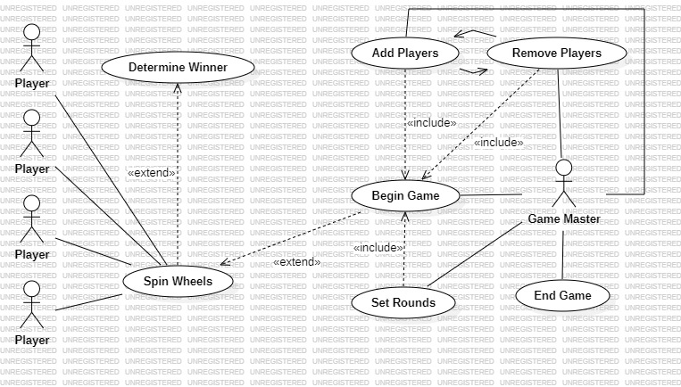

Section 2: Class Relationships + Diagram
Blitz – Main Program
- Store all gameplay constants  - Build and display the GUI elements  - Track all player related activity  - Store all critical game elements | - Player  - GoodWheel  - BadWheel  - ChaosWheel  - playerList

Player
- Stores Player information  - Sets the state of every player depending on game actions | - Name  - Coin count  - isCursed

Wheel
- Abstract class that sets the default construction of each wheel  - Sets the cost of each wheel and charges for its use  - Allows spinning of each wheel | - wheelSpin  - wheel weight  - wheel cost

Good/Bad/Chaos Wheels
- Takes the Wheel constructor and uses their own individual values  - Takes the spin of the wheel and has their own effects depending on where it lands | - spinGood/Bad/ChaosWheel

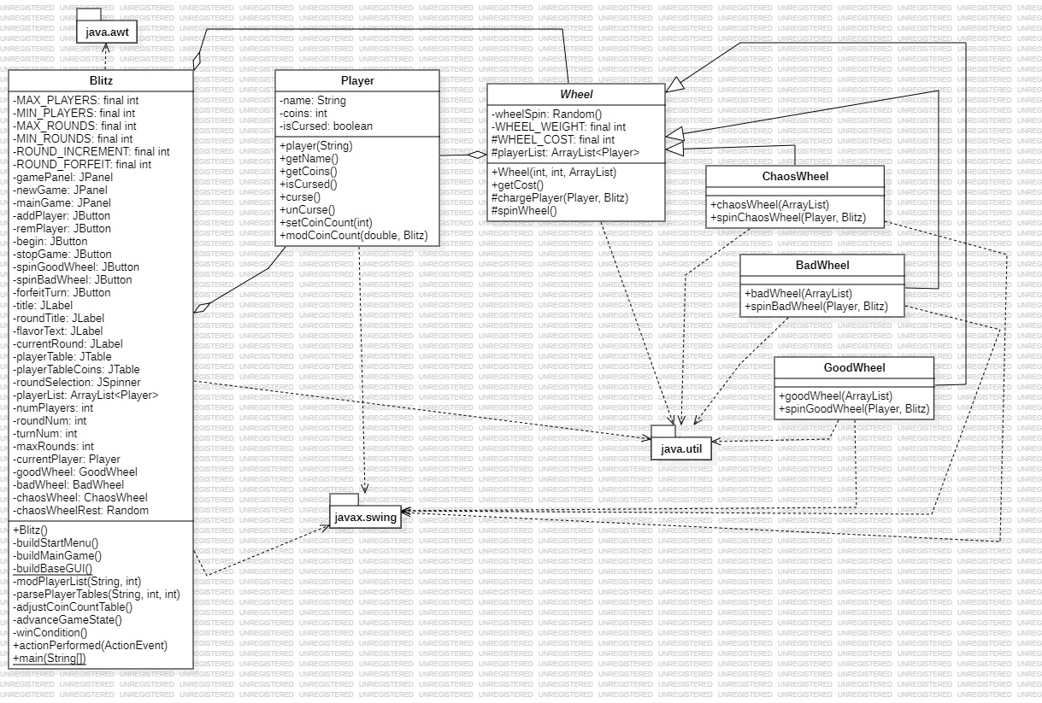
Section 3: Sequence of Generalized Events
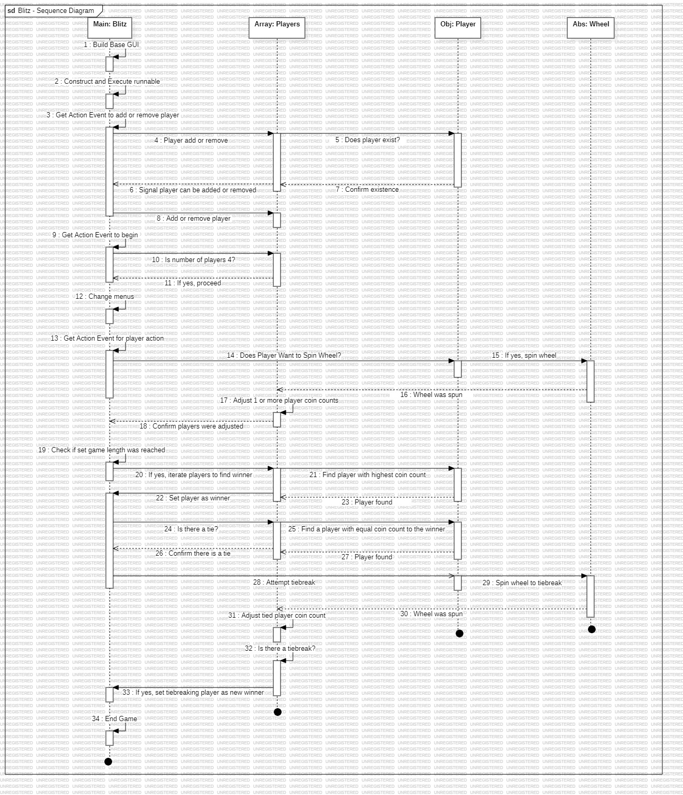



Section 4: GUI Wireframe and Usage Guide

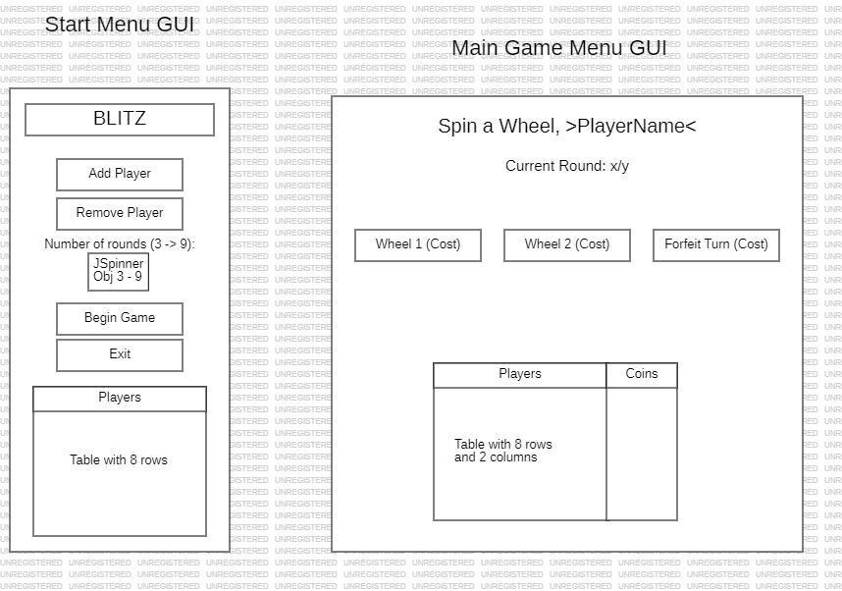
2.5
2.4
2.3
2.2
2.1
1.6
1.5
1.4
1.3
1.2
1.1

General Usage Instructions

- Press the “Add Player”_{1.1} button to add a participant; a text popup will appear so the name can be entered. When done, and a valid name is added (no blank names), the name will appear in the Table labeled “Players”_{1.2}
  - If a player wants to be removed from the game, press the “Remove Player”_{1.3} button; a text popup will appear so the name can be entered. When done, and a valid name is added (the name esists in the player list), the player will be removed.
  - Alternatively, if the game should need to be ended, then the “Exit”_{1.4} button can be pressed as well.
- The JSpinner Object, labeled with “Number of Rounds”_{1.5} can adjust the number of rounds to be played before the game begins, with a number between 3 and 9.
- To start the game, press “Begin Game”_{1.6}. The Start menu will disappear and be replaced by the main game menu.
  - If the number of players is lower than 4, a popup will apear stating that at least 4 players are needed to begin.
  - Additionally, popups will apear for trying to add more than 9 players, trying to remove players when 0 exist, and tyring to add a player that has already been added.
- Each player will be initialized with a certain amount of coins in the table labeled “Players” and “Coins”_{2.1}.
- To spin a wheel or forfeit a round, press one of the three buttons presented; 2 are wheels to spin_{2.2}, and 1 is to forfeit_{2.3}. Once pressed, a popup will notify of the effect the selection had and the table will update.
  - In the full program, the first wheel has a negative cost; if the player cannot afford the cost, then a popup will notify that another selection must be made.
  - When the Chaos Wheel advances its rest state, this will be relayed through a popup. When it needs to be spun by a player, then this will also be relayed.
- During these processes, the name label_{2.4} will update to the name of the player whose turn it is, and the round counter_{2.5} will increment once all players in the tabel have been cycled through.
- Once all rounds are complete, the winner will be determined; if a tie is detected, then a few popups will display an attempted tiebreak.
  - If the tiebreak succeeds, then the process will repeat until there is 1 true winner.
- Once a true winner is determined, they will be delcared and the program will exit.

Section 5: Raw Code Files of Final Program

FILE 1 – Blitz.java

package blitz_gui;

import java.util.*;
import java.awt.*;
import java.awt.event.*;
import javax.swing.*;
import javax.swing.table.TableColumnModel;

/**
* BLITZ : The Ultimate Game of Chance!
*
* This is a simple multiplayer game for up to 8 people that
* intended to play much like a party game, with mostly random
* elements that add to both the chaotic nature of such games
* while encouraging replayability.
*
* @author Taylor Fanel-Luevano
* @version 1.1
*/
public class Blitz extends JFrame implements ActionListener {
private final int MAX_PLAYERS = 8, // player/round count related limits
MIN_PLAYERS = 4,
MAX_ROUNDS = 9,
MIN_ROUNDS = 3,
ROUND_INCREMENT = 3,
ROUND_FORFEIT = -1; // determines the cost for forfeiting a turn

private JPanel gamePanel = new JPanel(new GridBagLayout()), // JPanels for all GUI elements
newGame = new JPanel(new GridBagLayout()), // each one uses a GridBag layout
mainGame = new JPanel(new GridBagLayout());

private JButton addPlayer = new JButton("Add PLayer"), // Buttons for all player functions
remPlayer = new JButton("Remove Player"),
begin = new JButton("Begin Game"),
stopGame = new JButton("Exit"),
spinGoodWheel = new JButton(), // No labels as they are established later
spinBadWheel = new JButton(),
forfeitTurn = new JButton();

private JLabel title = new JLabel("BLITZ"), // Labels for all related elements
roundTitle = new JLabel("Number of Rounds ("+MIN_ROUNDS+" -> "+MAX_ROUNDS+"):"),
flavorText = new JLabel("Spin a wheel if you dare, %s..."), // Placeholder Labels; prevents a critical
currentRound = new JLabel("Current Round: %d"); // bug where the table isn't sized properly

private JTable playerTable, // Tables to keep track of player activity
playerTableCoins;

private JSpinner roundSelection; // Spinner to set the number of rounds

private ArrayList<Player> playerList = new ArrayList<Player>(); // Array that stores all player objects

private int numPlayers = 0, // Game variables that are dynamic each game
roundNum = 1,
turnNum = 0,
maxRounds;

private Player currentPlayer; // Stores the player that currently has a turn

private final GoodWheel goodWheel = new GoodWheel(playerList); // Wheel objects for the game
private final BadWheel badWheel = new BadWheel(playerList);
private final ChaosWheel chaosWheel = new ChaosWheel(playerList);

private Random chaosWheelRest; // Unique random generator for the ChaosWheel

/**
* Constructor for the main game window
* @see Blitz#buildStartMenu()
* @see Blitz#buildMainGame()
*/
public Blitz() {
setTitle("BLITZ");
setResizable(false);
add(gamePanel);

// builds the primary game menus
buildStartMenu();
buildMainGame();
mainGame.setVisible(false); // So the main game menu doesn't overlap the start menu

GridBagConstraints l = new GridBagConstraints();
l.insets = new Insets(10, 10, 10, 10);
l.fill = GridBagConstraints.HORIZONTAL;
l.gridx = 0;
l.gridy = 0;
gamePanel.add(newGame, l);
l.insets = new Insets(10, 10, 10, 10);
l.fill = GridBagConstraints.HORIZONTAL;
l.gridx = 0;
l.gridy = 0;
gamePanel.add(mainGame, l);
}

/**
* Contructs the start menu, allowing the addition and
* removal of players and setting the number of rounds
*/
private void buildStartMenu() {
String[] nameListHeading = {"Players"}; // String arrays to store into the table
String[][] playerNameList = new String[MAX_PLAYERS][1];

addPlayer.setPreferredSize(new Dimension(120, 25));
addPlayer.addActionListener(this);
remPlayer.setPreferredSize(new Dimension(120, 25));
remPlayer.addActionListener(this);
begin.setPreferredSize(new Dimension(120, 25));
begin.addActionListener(this);
stopGame.setPreferredSize(new Dimension(120, 25));
stopGame.addActionListener(this);

SpinnerNumberModel m = new SpinnerNumberModel(MIN_ROUNDS, MIN_ROUNDS, MAX_ROUNDS, ROUND_INCREMENT);
roundSelection = new JSpinner(m);

// playerTable stores just the names of the players
playerTable = new JTable(playerNameList, nameListHeading);
playerTable.setEnabled(false); // To prevent editing of the table
TableColumnModel t = playerTable.getColumnModel();
t.getColumn(0).setPreferredWidth(150);

title.setFont(new Font("Comic Sans MS", Font.BOLD, 18));
roundTitle.setFont(new Font("Comic Sans MS", Font.PLAIN, 14));

GridBagConstraints l = new GridBagConstraints();
l.insets = new Insets(15, 10, 15, 10); // Top portion (Title -> Round selector)
l.fill = GridBagConstraints.CENTER;
l.gridx = 0;
l.gridy = 0;
newGame.add(title, l);
l = new GridBagConstraints();
l.insets = new Insets(1, 30, 1, 30);
l.fill = GridBagConstraints.CENTER;
l.gridx = 0;
l.gridy = 1;
newGame.add(addPlayer, l);
l = new GridBagConstraints();
l.insets = new Insets(1, 30, 3, 30);
l.fill = GridBagConstraints.CENTER;
l.gridx = 0;
l.gridy = 2;
newGame.add(remPlayer, l);
l = new GridBagConstraints();
l.insets = new Insets(2, 30, 1, 30);
l.fill = GridBagConstraints.CENTER;
l.gridx = 0;
l.gridy = 3;
newGame.add(roundTitle, l);
l = new GridBagConstraints();
l.insets = new Insets(1, 30, 15, 30);
l.fill = GridBagConstraints.CENTER;
l.gridx = 0;
l.gridy = 4;
newGame.add(roundSelection, l);

l = new GridBagConstraints(); // Middle poriton (Begin and exit buttons)
l.insets = new Insets(1, 30, 1, 30);
l.fill = GridBagConstraints.CENTER;
l.gridx = 0;
l.gridy = 5;
newGame.add(begin, l);
l = new GridBagConstraints();
l.insets = new Insets(1, 30, 15, 30);
l.fill = GridBagConstraints.CENTER;
l.gridx = 0;
l.gridy = 6;
newGame.add(stopGame, l);
l = new GridBagConstraints();
l.insets = new Insets(5, 10, 0, 10);
l.fill = GridBagConstraints.CENTER;
l.gridx = 0;
l.gridy = 7;

newGame.add(playerTable.getTableHeader(), l); // Player table
l = new GridBagConstraints();
l.insets = new Insets(0, 10, 15, 10);
l.fill = GridBagConstraints.CENTER;
l.gridx = 0;
l.gridy = 8;
newGame.add(playerTable, l);
}

/**
* Builds the main game window when the start menu confirms
* everything can begin
* @see Wheel#getCost()
*/
private void buildMainGame() {
String[] nameListHeading = {"Players", "Coins"}; // String arrays to store into the table
String[][] playerStatList = new String[MAX_PLAYERS][2];
JPanel flavorPanel = new JPanel(new GridBagLayout()), // 2 new Panels to separate the titles and buttons
buttonPanel = new JPanel(new GridBagLayout());
setLayout(new GridBagLayout());

// Uses the .getCost() function of Wheel to properly display the button text
spinGoodWheel.setText("Good Wheel ("+goodWheel.getCost()+")");
spinGoodWheel.setPreferredSize(new Dimension(125, 25));
spinGoodWheel.addActionListener(this);
spinBadWheel.setText("Bad Wheel ("+badWheel.getCost()+")");
spinBadWheel.setPreferredSize(new Dimension(125, 25));
spinBadWheel.addActionListener(this);
forfeitTurn.setText("Forfeit Turn ("+ROUND_FORFEIT+")");
forfeitTurn.setPreferredSize(new Dimension(125, 25));
forfeitTurn.addActionListener(this);

// playerTableCoins stores the name + coin counts of each player
playerTableCoins = new JTable(playerStatList, nameListHeading);
playerTableCoins.setEnabled(false);
TableColumnModel t = playerTableCoins.getColumnModel();
t.getColumn(0).setPreferredWidth(150);
t.getColumn(1).setPreferredWidth(50);

flavorText.setFont(new Font("Comic Sans MS", Font.BOLD, 18));
currentRound.setFont(new Font("Comic Sans MS", Font.PLAIN, 14));

GridBagConstraints l = new GridBagConstraints();
l.insets = new Insets(0, 0, 20, 0); // adds the new panels to the main game panel
l.fill = GridBagConstraints.CENTER;
l.gridx = 0;
l.gridy = 0;
mainGame.add(flavorPanel, l);
l = new GridBagConstraints();
l.insets = new Insets(20, 0, 0, 0);
l.fill = GridBagConstraints.CENTER;
l.gridx = 0;
l.gridy = 1;
mainGame.add(buttonPanel, l);

l = new GridBagConstraints(); // top portion (Titles for the main game)
l.insets = new Insets(5, 0, 5, 0);
l.fill = GridBagConstraints.NORTH;
l.gridx = 1;
l.gridy = 0;
flavorPanel.add(flavorText, l);
l = new GridBagConstraints();
l.insets = new Insets(5, 0, 0, 0);
l.fill = GridBagConstraints.NORTH;
l.gridx = 1;
l.gridy = 1;
flavorPanel.add(currentRound, l);

l = new GridBagConstraints(); // middle portion (buttons to press for player action)
l.insets = new Insets(0, 20, 50, 15);
l.fill = GridBagConstraints.HORIZONTAL;
l.gridx = 0;
l.gridy = 2;
buttonPanel.add(spinGoodWheel, l);
l = new GridBagConstraints();
l.insets = new Insets(0, 20, 50, 20);
l.fill = GridBagConstraints.HORIZONTAL;
l.gridx = 1;
l.gridy = 2;
buttonPanel.add(spinBadWheel, l);
l = new GridBagConstraints();
l.insets = new Insets(0, 15, 50, 20);
l.fill = GridBagConstraints.HORIZONTAL;
l.gridx = 2;
l.gridy = 2;
buttonPanel.add(forfeitTurn, l);

l = new GridBagConstraints(); // bottom portion (playerCoinTable)
l.insets = new Insets(50, 0, 0, 0);
l.fill = GridBagConstraints.CENTER;
l.gridx = 0;
l.gridy = 2;
mainGame.add(playerTableCoins.getTableHeader(), l);
l = new GridBagConstraints();
l.insets = new Insets(0, 0, 15, 0);
l.fill = GridBagConstraints.CENTER;
l.gridx = 0;
l.gridy = 3;
mainGame.add(playerTableCoins, l);
}

/**
* Constructs all the elements into the main GUI window
*/
private static void buildBaseGUI() {
Blitz gameWindow = new Blitz();
gameWindow.setDefaultCloseOperation(EXIT_ON_CLOSE);
gameWindow.pack();
gameWindow.setVisible(true);
gameWindow.setLocationRelativeTo(null); // So it always centers on the screen
}

/**
* Modifies the Player array to add or remove players from it.
* @param name - player name
* @param opCode - the operation code - is the player being added (1) or removed (2)?
* @return a boolean to confirm if the player table was updated or not
* @see Blitz#parsePlayerTables(String, int, int)
*/
private boolean modPlayerList(String name, int opCode) {
boolean hasListBeenModded = false; // boolean to return
boolean canPlayerBeAdded = true; // boolean to check if the player can be added to the list

// if a player is trying to be added...
if (opCode == 1) {
/* Check if the player name is empty
if it isn't, then check if the player list already contains the player.
if either check fails, then set canPlayerBeAdded to false */
if (name.trim().isEmpty()) canPlayerBeAdded = false;
else if (numPlayers != 0) {
for (int i = 0; i < numPlayers; i++) {
if (name.equals(playerList.get(i).getName())) {
canPlayerBeAdded = false;
break;
}
}
}
// If the player can be added, then attempt to add them; otherwise, deny the operation
if (canPlayerBeAdded) {
Player newPlayer = new Player(name);
playerList.add(newPlayer);
numPlayers++;
parsePlayerTables(name, opCode, numPlayers);
hasListBeenModded = true; // Operation was successful
}
// If a player is trying to be removed...
} else if (opCode == 2) {
// Check if the player exists in the list; if they do, then attempt to remove them
for (int i = 0; i < numPlayers; i++) {
if (name.equals(playerList.get(i).getName())) {
playerList.remove(i);
numPlayers--;
parsePlayerTables(name, opCode, i+1);
hasListBeenModded = true;
break;
}
}
}

// If it returns true, then the Player list was successfully adjusted
return hasListBeenModded;
}

/**
* Updates the player JTables to add or remove the names of players being
* added/removed
* @param name - name of the player
* @param opCode - operation code; 1 for add, 2 for remove
* @param playerNum - stores the index the player is to be added to/removed from
*/
private void parsePlayerTables(String name, int opCode, int playerNum) {

// If a player is being added...
if (opCode == 1) {
// set the values at index playerNum of the tables to the player name.
playerTable.setValueAt(name, playerNum - 1, 0);
playerTableCoins.setValueAt(name, playerNum - 1, 0);
// If a player is being removed...
} else if (opCode == 2) {
// set the values at index playerNum of the tables to null.
playerTable.setValueAt(null, playerNum - 1, 0);
playerTableCoins.setValueAt(null, playerNum - 1, 0);

// Once removed, check if the number of players is greater than 0. If not...
if (numPlayers != 0) {
// Iterate each filled index slot in the tables and update the names to remove any gaps in the list
for (int i = playerNum - 1; i < numPlayers; i++) {
playerTable.setValueAt(playerTable.getValueAt(i+1, 0), i, 0);
playerTableCoins.setValueAt(playerTable.getValueAt(i+1, 0), i, 0);
}
}
// Finally, if the number of players is not at maximum, set the last index value to null to remove dupes
if (numPlayers != MAX_PLAYERS) {
playerTable.setValueAt(null, numPlayers, 0);
playerTableCoins.setValueAt(null, numPlayers, 0);
}
}
}

/**
* Adjust the coins displayed for each player in playerTableCoins.
* @see Player#getCoins()
* @see Player#isCursed()
* @see Player#getName()
*/
private void adjustCoinCountTable() {
String coins; // stores the coins of each player

// iterate through the Player list and update each coin value in the table
for (int i = 0; i < numPlayers; i++) {
coins = Integer.toString(playerList.get(i).getCoins());
if (!playerTableCoins.getValueAt(i, 1).equals(coins))
playerTableCoins.setValueAt(coins, i, 1);

// If a player is cursed, then additionally add (CURSED!) to their name in the table
if (playerList.get(i).isCursed())
playerTableCoins.setValueAt(playerList.get(i).getName()+" (CURSED!)", i, 0);

// Failsafe as the cursed effect text is not updated anywhere else
else playerTableCoins.setValueAt(playerList.get(i).getName(), i, 0);
}
}

/**
* Advances to the next player that has a turn, and advances
* the round if all players had a turn.
* Additionally has functionality for the activation of the
* Chaos Wheel.
* @see Blitz#winCondition()
* @see Blitz#adjustCoinCountTable()
* @see Blitz#advanceGameState()
* @see Player#getName()
* @see ChaosWheel#isExhausted()
* @see ChaosWheel#spinChaosWheel(Player, Blitz)
*/
private void advanceGameState() {
int chaosAdvance; // Determines if the Chaos Wheel must be spun

// This function assumes a player has completed their turn, so the turn num always increments first
turnNum++;

// If the turn num is equal to the number of players, then the round is complete and advances to the next round
if (turnNum == numPlayers) {
roundNum++;
if (roundNum == maxRounds + 1) winCondition(); // If the rounds exceed the max, the game is complete
turnNum = 0;
currentRound.setText("Current Round: "+roundNum+"/"+maxRounds);
}
// Once the turn logic is complete, use turnNum to parse the index of the next player to get a turn
currentPlayer = playerList.get(turnNum);
flavorText.setText("Spin a wheel if you dare, "+currentPlayer.getName()+"...");

// Since the Chaos wheel requires no input, it is handled separately to the other 2 wheels
chaosWheelRest = new Random(); // A number between 1 and the number of players/2 is chosen
chaosAdvance = chaosWheelRest.nextInt(numPlayers/2)+1;

/* If the number rolled is the maximum number that can be rolled
(i.e. 2 for a 4 player game, 4 for an 8 player) and the Chaos Wheel
is not in its resting state, then the Chaos wheel must be spun for the next player */
if (chaosAdvance == numPlayers/2 && !chaosWheel.isExhausted()) {
chaosWheel.spinChaosWheel(currentPlayer, this);
adjustCoinCountTable(); // Performs all the logic for spinning a wheel, including recursively calling the function
advanceGameState();
}
}

/**
* When all rounds are done, determine the winner of the game.
* @see Player#getCoins()
* @see Player#getName()
* @see GoodWheel#spinGoodWheel(Player, Blitz)
* @see Blitz#adjustCoinCountTable()
*/
private void winCondition() {
Player winner = playerList.get(0); // The first player in the Player list is assumed the winner initially

// Iterates through the player list to determine who has higher coin counts
for (Player win : playerList) {
if (win.getCoins() > winner.getCoins()) winner = win;
}

// Iterate a second time to confirm any ties
for (Player win : playerList) {

// Tiebreak by forcing the competing winner to spin the good wheel
if (win.getCoins() == winner.getCoins() && !win.getName().equals(winner.getName())) {
JOptionPane.showMessageDialog(this, "Tied score by "+winner.getName()+" and "+win.getName()+"!"+
"\nTiebreak the winner by spinning the good wheel!");
flavorText.setText("SUDDEN DEATH, SPIN THE WHEEL "+win.getName()+"!");
currentRound.setText("Current Round: !!!");
goodWheel.spinGoodWheel(win, this);

// Display if the tiebreak succeeded or not
if (win.getCoins() > winner.getCoins())
JOptionPane.showMessageDialog(this, "Tiebreak! "+win.getName()+" now has a higher coin count!");
else JOptionPane.showMessageDialog(this, "Tiebreak failed "+win.getName()+"...sorry.");

/* To take into account any unexpected outcomes (such as a losing player
suddenly gaining enought coins to win outright or compete for the win),
the function is recursively called */
winCondition();
}
}

adjustCoinCountTable(); // So the winner's coins are properly displayed
JOptionPane.showMessageDialog(this, winner.getName()+" has won the game of BLITZ! Congratulations!");
System.exit(0);
}

@Override
/**
* The action event to handle any button usage.
* @see Blitz#modPlayerList(String, int)
* @see Blitz#advanceGameState()
* @see Blitz#adjustCoinCountTable()
* @see Player#getName()
* @see Player#getCoins()
* @see Player#modCoinCount(double, Blitz)
* @see GoodWheel#spinGoodWheel(Player, Blitz)
* @see BadWheel#spinBadWheel(Player, Blitz)
* @see ChaosWheel#spinChaosWheel(Player, Blitz)
* @see ChaosWheel#rest()
*/
public void actionPerformed(ActionEvent op) {
JButton src = (JButton)op.getSource(); // Gets the operation button
String name; // For when a player is being added/removed
int chaosAdvance; // For when a player completes their turn

// Operation 1: Adding a player
if (src == addPlayer) {

// First check if the player list is full
if (numPlayers == MAX_PLAYERS) {
JOptionPane.showMessageDialog(this, "No more players can be added.");
} else {

// Enter a name to be added; the null check is if the op is canceled
name = JOptionPane.showInputDialog(this, "Enter player name");
if (name != null) {

// Try to add the player, and notify if they were successfully added
if (modPlayerList(name, 1))
JOptionPane.showMessageDialog(this, "Player added!");
else JOptionPane.showMessageDialog(this, "Player can't be added.");
}
}
// Operation 2: Removing a player
} else if (src == remPlayer) {

// First check if there are even players to remove
if (numPlayers == 0) {
JOptionPane.showMessageDialog(this, "But...there aren't any players.");
} else {

// Enter a name to be removed; the null check is if the op is canceled
name = JOptionPane.showInputDialog(this, "Enter player name");
if (name != null) {

// Try to remove the player, and notify if they were successfully removed
if (modPlayerList(name, 2))
JOptionPane.showMessageDialog(this, "Player removed...");
else JOptionPane.showMessageDialog(this, "That player doesn't exist.");
}
}
// Operation 3: Starting the game
} else if (src == begin) {
maxRounds = (Integer)roundSelection.getValue(); // Get the desired round count from the JSpinner

// First check if the game has the minimum amount of required players
if (numPlayers < MIN_PLAYERS) {
JOptionPane.showMessageDialog(this, "This game needs "+MIN_PLAYERS+" or more players to begin.");
} else {

/* Notify the number of rounds to be played and run logic to
switch from the start menu to the main game menu*/
JOptionPane.showMessageDialog(this, "The game begins! (Play for "+maxRounds+" rounds)");
newGame.setVisible(false);
mainGame.setVisible(true);
pack();
setLocationRelativeTo(null);

/* Initialize the coin counts on playerTableCoins (the names were
already handled by the parsePlayerTables function) */
for (int i = 0; i < numPlayers; i++) {
playerTableCoins.setValueAt(Integer.toString(playerList.get(i).getCoins()), i, 1);
}

currentPlayer = playerList.get(turnNum); // As turnNum is initialized to 0, there is no need to run advanceGameState() yet
flavorText.setText("Spin a wheel if you dare, "+currentPlayer.getName()+"...");
currentRound.setText("Current Round: 1/"+maxRounds);
}
// Operation 4: exiting the game
} else if (src == stopGame) {
System.exit(0); // If the exit button on the start menu is pressed
} else {
// If the op is not any of the above, it's assumed to come from the main game menu

// Operation 5: Spin the Good Wheel
if (src == spinGoodWheel) {

// If the player can't afford the cost, then notify; otherwise, let them spin it
if (currentPlayer.getCoins() < Math.abs(goodWheel.getCost()))
JOptionPane.showMessageDialog(this, "You cannot afford to spin the good wheel "+currentPlayer.getName());
else {
goodWheel.spinGoodWheel(currentPlayer, this);
adjustCoinCountTable();
advanceGameState();
}
// Operation 6 and 7: Spin the Bad Wheel or Forfeit the turn
} else {

// Let the player spin the Bad Wheel
if (src == spinBadWheel) badWheel.spinBadWheel(currentPlayer, this);

// If it wasn't the Bad Wheel, then the player is assumed to have forfeited their turn
else {
JOptionPane.showMessageDialog(this, currentPlayer.getName()+" has forfeited their turn.");
currentPlayer.modCoinCount(ROUND_FORFEIT, this);
}
adjustCoinCountTable();
advanceGameState();
}

// Logic that runs after any of the main game buttons were pressed

chaosWheelRest = new Random(); // A number between 1 and the number of players/2 is chosen
chaosAdvance = chaosWheelRest.nextInt(numPlayers/2)+1;

/* If the number rolled is the maximum number that can be rolled
(i.e. 2 for a 4 player game, 4 for an 8 player) and the Chaos Wheel
is in its resting state, then the Chaos wheel advances its resting state */
if (chaosWheel.isExhausted() && chaosAdvance == numPlayers/2) chaosWheel.rest(this);
}
}

/**
* Runs the executable
* @param args - command-line arguments
* @see Blitz#buildBaseGUI()
*/
public static void main(String[] args) {
SwingUtilities.invokeLater(new Runnable() {
public void run() {
buildBaseGUI();
}
});
}
}

FILE 2 – Player.java

package blitz_gui;

import javax.swing.JOptionPane;

/**
* This is the Player class that stores the info of any
* player that participates in the game.
*
* @author Taylor Fanel-Luevano
* @version 1.1
*/
public class Player {
private String name; // Stores their name
private int coins = 5; // Stores their coin count; initialized to 5
private boolean isCursed = false; // Checks if they're cursed; initially false

/**
* Creates a player object and gives it a name.
* @param playerName - the name to be given to the new player object
*/
public Player(String playerName) {
name = playerName;
}

/**
* Fetches the player name.
* @return name of the player
*/
public String getName() {
return name;
}

/**
* Fetches the player coint count.
* @return coin count of the player
*/
public int getCoins() {
return coins;
}

/**
* Checks if the player is cursed or not.
* @return a boolean to check if player is cursed
*/
public boolean isCursed() {
return isCursed;
}

/**
* Curses the player.
*/
public void curse() {
isCursed = true;
}

/**
* Un-curses the player.
*/
public void unCurse() {
isCursed = false;
}

/**
* Modifies the player's coint count directly, without involving
* the curse status effect.
* @param modifier - the % modifier to apply to the player's coins
*/
public void setCoinCoint(int modifier) {
coins = modifier;
}

/**
* Increases or decreases the coin count based on what a spin
* has done to the player.
* @param coinsToMod - the number of coins to add or subtract
* @param main - the main menu; used to display the message
*/
public void modCoinCount(double coinsToMod, Blitz main) {

// First check if the player is cursed and if their coin gains are at least 1
if (isCursed && coinsToMod > 0) {

// Apply the curse effect, cutting their coin gain in half
coins += (coinsToMod * 0.5);
isCursed = false; // After doing this, the player is cleared of the effect
JOptionPane.showMessageDialog(main, name+" has been cleansed at a loss of "+(int)(coinsToMod * 0.5)+" coins.");

// If none of the above is true, simply adjust the coin count.
} else coins += coinsToMod;

// Prevent the coin count from going below 0
if (coins < 0) coins = 0;
}
}

FILE 3 – Wheel.java

package blitz_gui;

import java.util.ArrayList;
import java.util.Random;

/**
* The abstract class that gives all the wheels base functionality and
* determines their constants.
*
* @author Taylor Fanel-Luevano
* @version 1.0
*/
public abstract class Wheel {
private Random wheelSpin = new Random(); // The seed that is generated for each wheel
private final int WHEEL_WEIGHT; // The 'weight' of each wheel section
protected final int WHEEL_COST; // The cost to spin the wheel
protected ArrayList<Player> playerList; /* The wheel is given a copy of the Player list ptr so
they can properly perform player-based operations */

/**
* Creates a wheel by setting its weight, cost, and the ptr to the Player list
* @param wheelWeight - sets WHEEL_WEIGHT
* @param cost - sets WHEEL_COST
* @param players - copies the playerlist ptr
*/
public Wheel(int wheelWeight, int cost, ArrayList<Player> players) {
WHEEL_WEIGHT = wheelWeight;
WHEEL_COST = cost;
playerList = players;
}

/**
* Fetches the cost of the wheel.
* @return the wheel cost
*/
public int getCost() {
return WHEEL_COST;
}

/**
* ...?
* Why did I think this was necessary? Well, I have
* no shame, so I'm keeping this here to remind anyone
* that you don't need to refresh a pointer to a list,
* okay?
* @param newList - just...does nothing basically.
*/
/* public void refreshPlayerList(ArrayList<Player> newList) {
playerList = newList;
} */

/**
* Charges the selected player based on the cost of the wheel.
* Can be positive, negative, or 0
* @param player - the player to charge
* @param menu - the main menu; used to pass to modCoinCount
* @see Player#modCoinCount(double, Blitz)
*/
protected void chargePlayer(Player player, Blitz menu) {
player.modCoinCount(WHEEL_COST, menu);
}

/**
* Spins the wheel and returns the number generated by
* wheelSpin, with a min of 1 and a max of the wheel weight
* @return The number from wheelSpin
*/
protected int spinWheel() {
return wheelSpin.nextInt(WHEEL_WEIGHT) + 1;
}
}

FILE 4 – GoodWheel.java

package blitz_gui;

import java.util.ArrayList;
import javax.swing.*;

/**
* The Good Wheel - it contains mostly positive
* effects for both you...and your opponents if
* luck isn't on your side.
*
* @author Taylor Fanel-Luevano
* @version 1.2
*/
public class GoodWheel extends Wheel {

/**
* Build the good wheel with a weight of 5 and a cost of -2 coins
* @param players - the Player list pointer
* @see Wheel#Wheel(int, int, ArrayList)
*/
public GoodWheel(ArrayList<Player> players) {
super(5, -2, players);
}

/**
* Spins the good wheel, with an effect based on the number
* spun by spinWheel().
* @param player - The player that spun the wheel
* @param menu - main menu; used to display messages
* @see Wheel#chargePlayer(Player, Blitz)
* @see Wheel#spinWheel()
* @see Player#modCoinCount(double, Blitz)
* @see Player#getName()
* @see Player#getCoins()
* @see Player#setCoinCoint(int)
* @see Player#curse()
*/
public void spinGoodWheel(Player player, Blitz menu) {
chargePlayer(player, menu); // Charge the player

int wheelSpin = spinWheel(); // Spin the wheel to get a number
ArrayList<Player> dynamic; // Create a new ArrayList for specific ops

switch (wheelSpin) {

case 1: // Outcome 1

// Give the player a coin (essentially gives them the cost + 1)
JOptionPane.showMessageDialog(menu, player.getName()+" has gained 1 coin. Not bad!");
player.modCoinCount(-WHEEL_COST + 1, menu);

break;
case 2: // Outcome 2

// Give the player 2 coins (essentially gives them the cost + 2)
JOptionPane.showMessageDialog(menu, player.getName()+" has gained 2 coins. Now we're in business!");
player.modCoinCount(-WHEEL_COST + 2, menu);

break;
case 3: // Outcome 3

// Refund the player and give every other player 1 coin
JOptionPane.showMessageDialog(menu, player.getName()+" had their coins refunded and got everyone else +1 coin.");
player.modCoinCount(-WHEEL_COST, menu);
for (int i = 0; i < playerList.size(); i++) {
if (!playerList.get(i).getName().equals(player.getName()))
playerList.get(i).modCoinCount(1, menu);;
}
break;
case 4: // Outcome 4

// Give the cost of the wheel spin over to the poorest player
JOptionPane.showMessageDialog(menu, player.getName()+" gave the poorest player the cost of their wheel spin.");
dynamic = new ArrayList<Player>();

// Add every other player to the dynamic list and determine the poorest player among them
for (Player iterate : playerList) {
if (!iterate.getName().equals(player.getName())) dynamic.add(iterate);
}

Player poorest = dynamic.get(0);

for (Player iterate : dynamic) {
if (iterate.getCoins() <= poorest.getCoins())
poorest = iterate;
}

// Once determined, give the coins over to the poorest player
poorest.modCoinCount(-WHEEL_COST, menu);

break;
case 5: // Outcome 5

// Curse the richest player and cut their coins in half
JOptionPane.showMessageDialog(menu, player.getName()+" cursed the richest player and cut their coins in half!");
dynamic = new ArrayList<Player>();

// Add every other player to the dynamic list and determine the richest player among them
for (Player iterate : playerList) {
if (!iterate.getName().equals(player.getName())) dynamic.add(iterate);
}

Player richest = dynamic.get(0);

for (Player iterate : dynamic) {
if (iterate.getCoins() >= richest.getCoins())
richest = iterate;
}

// Once determined, halve the coins and curse the richest player
richest.setCoinCoint((int)(richest.getCoins() * 0.5));
richest.curse();

break;
}
}
}

FILE 5 – BadWheel.java

package blitz_gui;

import java.util.ArrayList;
import javax.swing.*;

/**
* The Bad Wheel - it gives you coins right off the
* bat, but it may come at a stronger price - for you,
* or for your opponents.
*
* @author Taylor Fanel-Luevano
* @version 1.2
*/
public class BadWheel extends Wheel {

/**
* Build the bad wheel with a weight of 5 and a 'cost' of +2 coins
* @param players - the Player list pointer
* @see Wheel#Wheel(int, int, ArrayList)
*/
public BadWheel(ArrayList<Player> players) {
super(5, 2, players);
}

/**
* Spins the bad wheel, with an effect based on the number
* spun by spinWheel().
* @param player - The player that spun the wheel
* @param menu - main menu; used to display messages
* @see Wheel#chargePlayer(Player, Blitz)
* @see Wheel#spinWheel()
* @see Player#modCoinCount(double, Blitz)
* @see Player#getName()
* @see Player#getCoins()
* @see Player#curse()
*/
public void spinBadWheel(Player player, Blitz menu) {
int prevCoinCount = player.getCoins(); /* Since the curse effect applies to the coins gained by
spinning the bad wheel, it's important to keep track of
what the previous coin count of the player was */

chargePlayer(player, menu); // Charge the player

int wheelSpin = spinWheel(); // Spin the wheel to get a number
ArrayList<Player> dynamic; // Create a new ArrayList for specific ops

switch (wheelSpin) {

case 1: // Otucome 1

// Subtract a coin (net gain overall)
JOptionPane.showMessageDialog(menu, player.getName()+" has lost a coin. Still a net gain, not bad!");
player.modCoinCount(-1, menu);

break;

case 2: // Outcome 2

// Subtract the earnings + 1
JOptionPane.showMessageDialog(menu, player.getName()+" has lost their earnings + 1 coin. Better luck next time.");
player.modCoinCount(-(player.getCoins() - prevCoinCount) - 1, menu);

break;

case 3: // Outcome 3

// Subtract the earnings and curse the player
JOptionPane.showMessageDialog(menu, player.getName()+" lost their earnings and have been cursed!");
player.modCoinCount(-(player.getCoins() - prevCoinCount), menu);
player.curse();

break;

case 4: // Outcome 4

// Steal 2 coins from the richest player
JOptionPane.showMessageDialog(menu, player.getName()+" stole 2 coins from the richest player!");
dynamic = new ArrayList<Player>();

// Add every other player to the dynamic list and determine the richest player among them
for (Player iterate : playerList) {
if (!iterate.getName().equals(player.getName())) dynamic.add(iterate);
}

Player richest = dynamic.get(0);

for (Player iterate : dynamic) {
if (iterate.getCoins() >= richest.getCoins())
richest = iterate;
}

// Once determined, take the coins from the richest player
player.modCoinCount(2, menu);
richest.modCoinCount(-2, menu);

break;

case 5: // Outcome 5

// Take the earnings and give it over to the poorest player
JOptionPane.showMessageDialog(menu, player.getName()+"'s earnings have been stolen by the poorest player!");
dynamic = new ArrayList<Player>();

// Add every other player to the dynamic list and determine the poorest player among them
for (Player iterate : playerList) {
if (!iterate.getName().equals(player.getName())) dynamic.add(iterate);
}

Player poorest = dynamic.get(0);

for (Player iterate : dynamic) {
if (iterate.getCoins() <= poorest.getCoins())
poorest = iterate;
}

// Once determined, remove the coins and give them to the poorest player
poorest.modCoinCount(player.getCoins() - prevCoinCount, menu);
player.modCoinCount(-(player.getCoins() - prevCoinCount), menu);

break;

}
}
}

FILE 6 – ChaosWheel.java

package blitz_gui;

import java.util.ArrayList;
import javax.swing.*;

/**
* The Chaos Wheel - If it awakens during a turn, there
* is always the risk of a player being forced to spin
* it. This chaos is a little limited, but no less nerve
* wracking.
*
* @author Taylor Fanel-Luevano
* @version 1.1
*/
public class ChaosWheel extends Wheel {

private boolean exhausted = true; // Checks if the Chaos Wheel is ready to spin
private int fatigue = 3; // Wheel fatigue; if at 0, then the Chaos Wheel is ready to spin

/**
* Build the bad wheel with a weight of 5 and a cost
* of 0 coins, since spinning it is involuntary.
* @param players - the Player list pointer
* @see Wheel#Wheel(int, int, ArrayList)
*/
public ChaosWheel(ArrayList<Player> players) {
super(5, 0, players);
}

/**
* Spins the bad wheel, with an effect based on the number
* spun by spinWheel().
* @param player - The player that spun the wheel
* @param menu - main menu; used to display messages
* @see Wheel#spinWheel()
* @see Player#modCoinCount(double, Blitz)
* @see Player#getName()
* @see Player#getCoins()
* @see Player#setCoinCoint(int)
* @see Player#curse()
* @see Player#unCurse()
*/
public void spinChaosWheel(Player player, Blitz menu) {

// Anounce the incoming spin
JOptionPane.showMessageDialog(menu, player.getName()+" has been forced to spin the Chaos Wheel!");

int wheelSpin = spinWheel(); /* Spin the wheel to get a number
(since the cost is 0, chargePlayer() would do nothing) */

switch (wheelSpin) {

case 1: // Outcome 1

// Do nothing
JOptionPane.showMessageDialog(menu, player.getName()+" has had...nothing happen to them."+
"\nChaos includes nothing happening, you know.");

break;

case 2: // Outcome 2

// Force another Chaos Wheelspin
JOptionPane.showMessageDialog(menu, player.getName()+" has...to spin the wheel again."+
"\nWho knows, you might get stuck in a loop!");
spinChaosWheel(player, menu);

break;

case 3: // Outcome 3

// Swap the curse values of each player
JOptionPane.showMessageDialog(menu, player.getName()+" un-cursed all cursed and cursed all not cursed."+
"\nIt's cursed-a-geddon! Or something, idk.");
for (int i = 0; i < playerList.size(); i++) {
if (playerList.get(i).isCursed()) playerList.get(i).unCurse();
else playerList.get(i).curse();
}

break;

case 4: // Outcome 4

// Reduce the player's coin count to 1
JOptionPane.showMessageDialog(menu, player.getName()+"'s finger slipped and lost all of their coins but 1."+
"\n...sorry?");
player.setCoinCoint(1);

break;

case 5: // Outcome 5

// Give the player 3 coins
JOptionPane.showMessageDialog(menu, player.getName()+" had defied all odds and gained +3 coins! Lucky you.");
player.modCoinCount(3, menu);
break;
}

fatigue++; // When spun, increase the wheel's fatigue

// Once fatigue is 3, set the Wheel to not be spun
if (fatigue == 3) {
JOptionPane.showMessageDialog(menu, "The Chaos wheel grows weary and wains...");
exhausted = true;
}
}

/**
* Advances the Chaos Wheel's rest stage by removing fatigue.
* @param menu - main menu, for displaying messages
*/
public void rest(Blitz menu) {
fatigue--; // Assumes the Chaos Wheel is advancing its rest stage, so decrement fatigue

// Display messages based on the state of fatigue
if (fatigue == 1) JOptionPane.showMessageDialog(menu, "The Chaos wheel stirs...");
else if (fatigue == 0) {
JOptionPane.showMessageDialog(menu, "The Chaos wheel rattles to life...");
exhausted = false; // Once fatigue is 0, set the Wheel as ready to spin
}
}

/**
* Checks if the Chaos Wheel is currently
* unable to be spun.
* @return if the wheel can be spun
*/
public boolean isExhausted() {
return exhausted;
}
}

